**Lab-01**

**Introduction to Java**

## Objectives:

Getting familiar with the Java development kit (JDK). Running your first Java program using CMD and an IDE.

**What is JDK?**

It's the full featured Software Development Kit for Java, including JRE, and the compilers and tools (like Java Debugger) to create and compile programs. JRE is required to run Java programs while JDK is required when you have to do some Java programming.

**Installing JDK for Windows**

1. Download the JDK from Oracle’s website. Choose the right JDK depending upon your system’s specifications.

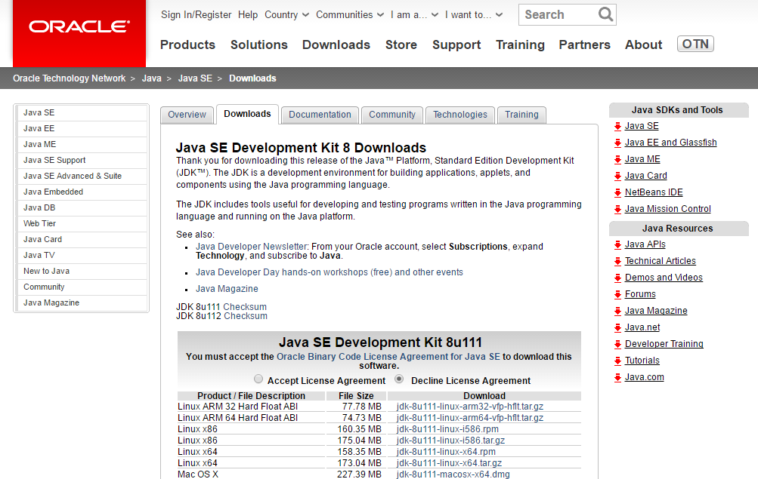

**Figure 1.1: Download the JDK from Oracle’s website**

1. Run the .exe file on your System and follow the steps as given by the installer.

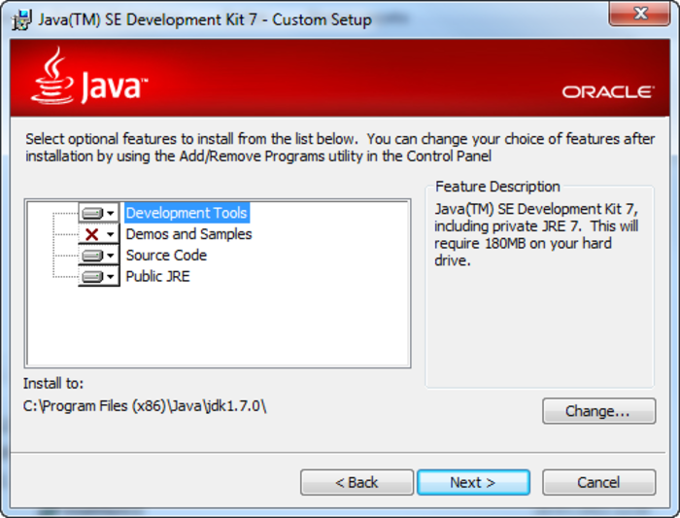

**Figure 1.2 Installing JDK**

1. Note down the location where j2se has been installed. Java Platform is also called as J2SE (Java 2 Platform Standard Edition)
2. Following screen will appear after successful installation.

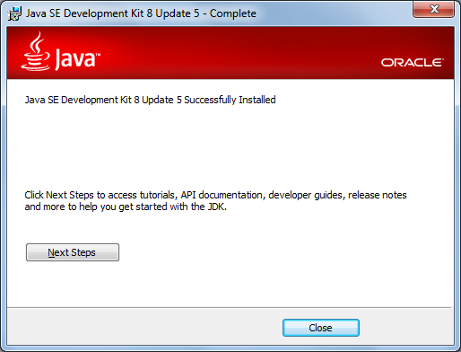

**Figure 1.3: Successful installation**

1. Post installation, you will need to set some environment variables in windows.
2. The path is required to be set for using tools such as javac, java etc.If you are saving the java source file inside the jdk/bin directory, path is not required to be set because all the tools will be available in the current directory. But If you are having your java file outside the jdk/bin folder, it is necessary to set path of JDK.

**Setting Java Path**

There are 2 ways to set java path:

1. temporary
2. permanent
3. **How to set Temporary Path of JDK in Windows**

To set the temporary path of JDK, you need to follow following steps:

* Open command prompt
* Copy the path of jdk/bin directory
* Design in command prompt: set path=copied_path

For Example:

set path=C:\Program Files\Java\jdk1.6.0_23\bin

Let's see it in the figure given below:

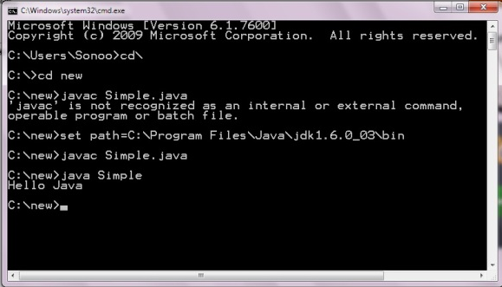

**Figure 1.4: Command Prompt**

1. **How to set Permanent Path of JDK in Windows**

For setting the permanent path of JDK, you need to follow these steps:

* Go to MyComputer properties -> advanced tab -> environment variables -> new tab of user variable -> Design path in variable name -> Design path of bin folder in variable value -> ok -> ok -> ok

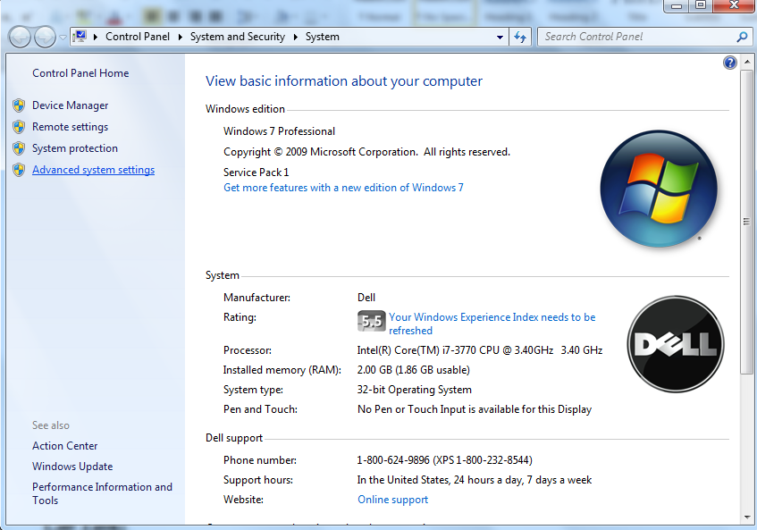

**Figure 1.5: Advance System Settings - Windows**

* Click on environment variables

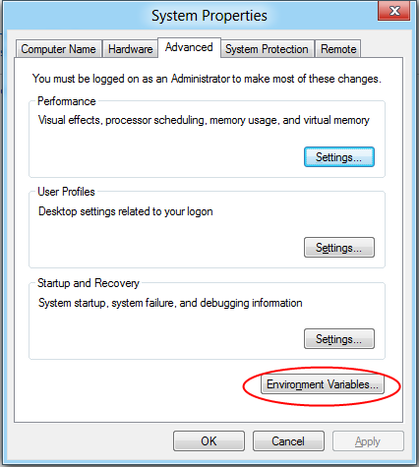

**Figure 1.6: Set Environment Variables**

* Select Path variable and click on Edit button.

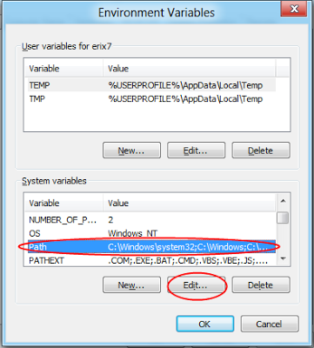

**Figure 1.7: Set Path Variable**

* Copy the path of the bin folder of the JDK and paste it in the variable value field of the path variable. So add ";C:\Program Files\Java\jdk1.7.0_02\bin" in the path string.

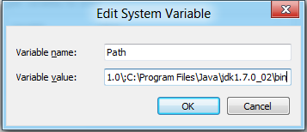

**Figure 1.8: Edit System Variable**

* Click OK... to finish.
* Now your permanent path is set. You can now execute any program of java from any drive.

**Note:**

The PATH environment variable is a series of directories separated by semicolons (;) and is not case-sensitive. Microsoft Windows looks for programs in the PATH directories in order, from left to right.

The new path takes effect in each new command window you open after setting the PATH variable.

**What is an IDE?**

An integrated development environment (IDE) is a software application that provides comprehensive facilities to computer programmers for software development. An IDE may consist of a source code editor; build automation tools, compiler and a debugger.

There are different IDE’s used for Java development including NetBeans and Eclipse.

Before starting to develop the complex programs, you need an IDE. In this workbook we will be using Eclipse IDE for code writing, compilation and execution.

**Install Eclipse IDE**

Download Eclipse form its official website and install it on your system by following the instruction provided by the installer.



**Figure 1.9: Download Eclipse IDE**

After installation, open eclipse. You will see the welcome screen.

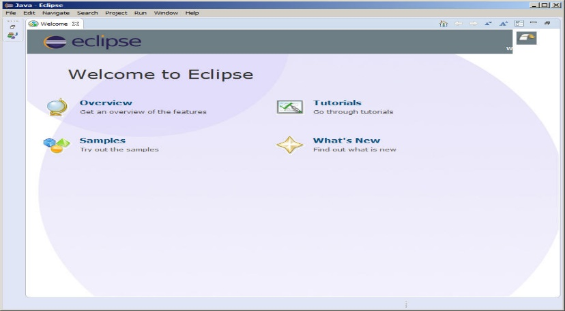

**Figure 1.10: Welcome Screen of Eclipse**

**Design a simple program in java, compile and run it using IDE.**

* Create new project in eclipse. Click on file menu, select Project, then select Java Project and click Next. You will see the following screen. Give your project a name and click Finish.

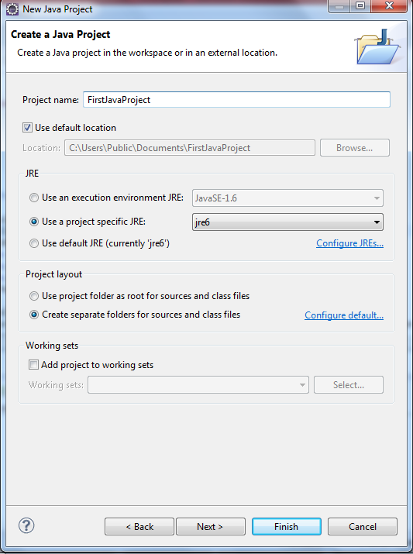

**Figure 1.11: Creating new project in Eclipse**

* Now right click on your project available in project explorer and create new class.

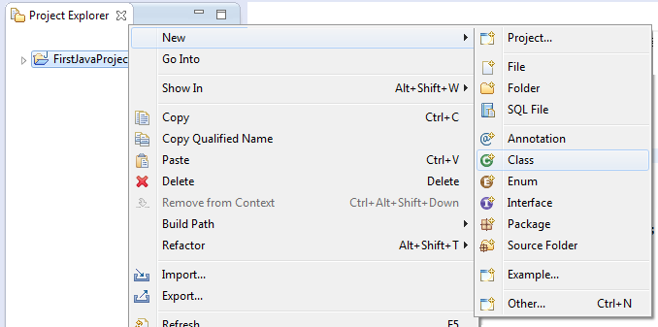

**Figure 1.12: Add new Class**

* A window similar to one shown below will appear. Enter the class name and check the checkbox for public static void main (String[] args). Click finish.

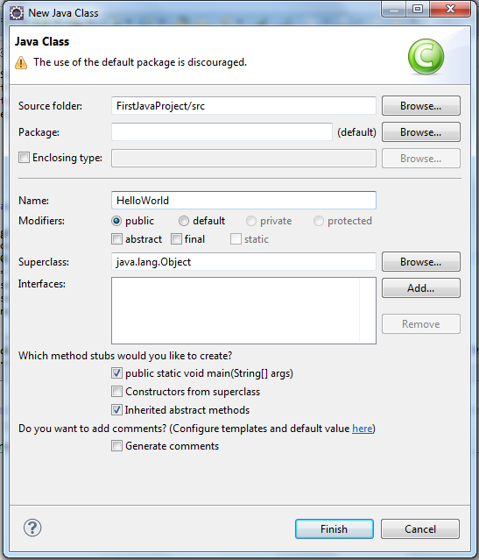

**Figure 1.13: Creating new Class**

* A java file will open with some added code. Just add the following line inside the main() method.System.out.println("Hello World!!");

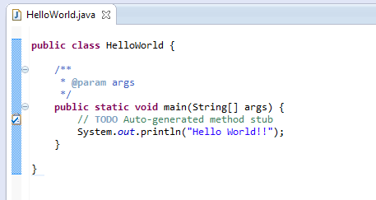

**Figure 1.14: Adding Java Code**

* Save the file.
* Now compile and execute this code. In Eclipse compilation and Execution performs by clicking the button highlighted in the image below.

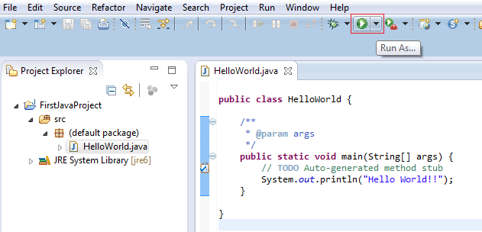

**Figure 1.15: compile& Execute**

* The output of this code will be generated in the console window present below.

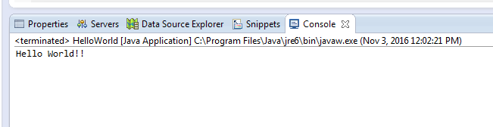

**Figure 1.16: Console Output**

**Lab Task:**

**Design a simple program in java, compile and run it using cmd.**

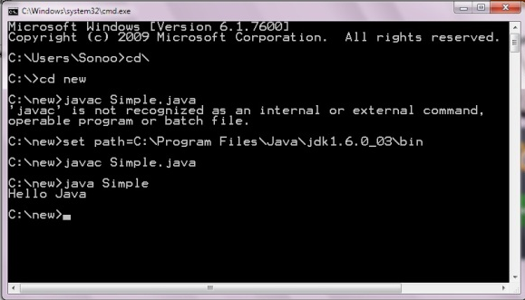

1. **Design a java program to print your bio data using java using IDE**

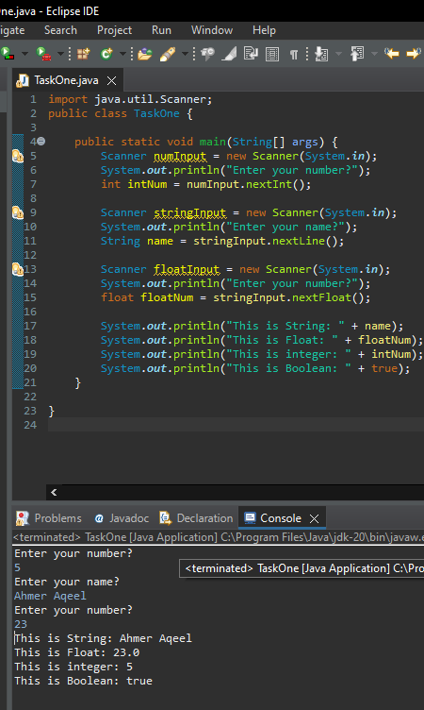

## Conclusion:

________________________________________________________________________________________________________________________________________________________________________________________________________________________________________________________________________________________________________________________________________________________________________________________________________________________________________________________________________________________________________________________________________________________________________________________________________________________________________________